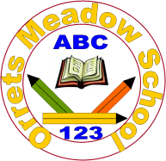
Governors Report – Summer 2021
English
Matthew Ferris
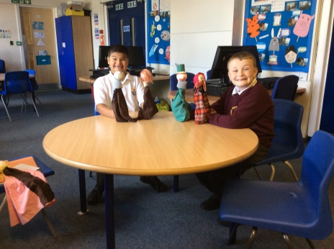
Achievements
During this academic year, pupils have continued to excel in English, despite all of the disruption caused by Covid. Through our annual reading tests it has been shown that the vast majority of pupils have continue to make excellent and rapid progress. Reading for pleasure has been at the forefront of many of the tasks undertaken in English this year.

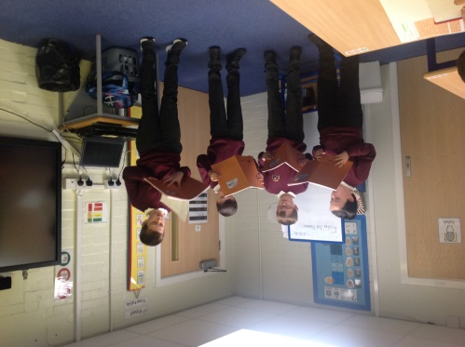
CPD
During this year I have been able to continue to attend both English subject leader meetings and moderation meetings hosted by Sarah Squared. This has been extremely beneficial to keep up to date with ever changing policies and national changes during the pandemic. It has also given me the opportunity to share and compare practice from other schools during lockdown and recovery.

I have been able to lead several staff meetings, including an inset day. During the inset day I introduced all staff to the book band system that was developed during summer term 2020 and the literacy spine that had been implemented at the same time. I also lead whole school meetings to introduce the new library system and to deliver phonics training, which is an area that some staff had specified that they would like training on during a staff survey.
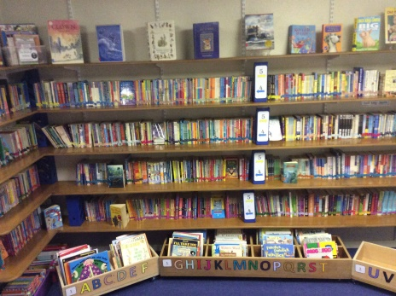
Reading for Pleasure at Orrets Meadow
Library: As previously mentioned reading for pleasure has been a real focus this year at Orrets Meadow. The library had been sorted out and promoted, with every class having a weekly time slot to attend the library and explore the books, as well as take them home to read. Pupils have become more vocal and varied about their favourite authors and books.
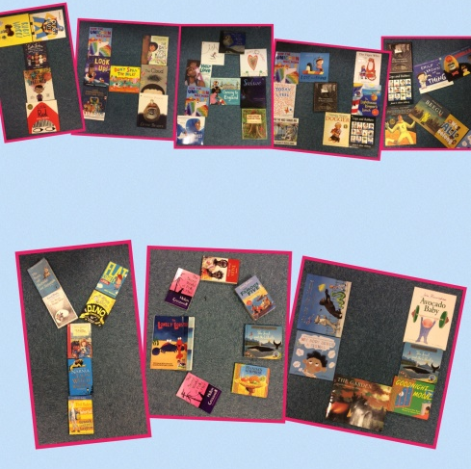
Amazon Wish List: This year in an attempt to update the library I created an Amazon wish list in order to update our library stock. There was a focus for stories with a BAME author or protagonist. As a school we were overwhelmed with the response from everyone in our school community including, staff, parents and governors. The pupils have loved sharing these new books and have been eager to see the new books arrive. This is something that I look forward to implementing again next year with a focus on non-fiction.
Class Reading Books: All classes are also taking part in daily reading sessions with their teacher sharing books from the literacy spine. These books provide an opportunity for pupils to enjoy stories without the expectation of work following. Pupils have really flourished and have shown a keen interest in finding out what books are being explored.
World Book Day: Unfortunately World Book Day this year fell during one of the national lockdowns. In order to make sure all pupils had the opportunity to take part in activities to explore literature I started a series of challenges for pupils to take part in. These encouraged pupils to explore their books through creative outlets like drama and art. Pupils at home really enjoyed this and sent in pictures of their exploits.

Quality of teaching learning
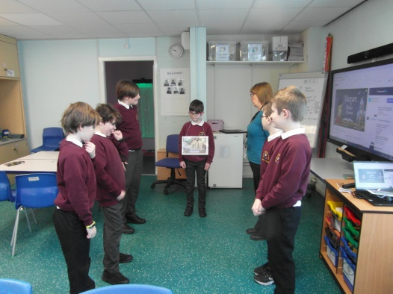
As the English subject leader, I have completed a range of activities to oversee English this year. During the autumn term, I implemented new reading systems throughout the school and delivered a staff inset day for all staff. I ensured that the most recent versions of the English, Writing and Reading for Pleasure policies, updated by myself in June 2020 were shared with staff. I collected reading data to compare the reading scores, Orrets Meadow book band system and Bug Club book bands. I also conducted a book scrutiny to monitor the implementation of the new English curriculum. This showed that all classes were following the new English long term plan and that work in the books was appropriate to the levels of the pupils.
In the spring term, I again collated reading data to look for any trends around the school, finding that girls were performing slightly better than boys, however this was a marginal difference. I collected staff surveys to review how the book band and library systems where going and pupil voices to monitor pupils growing awareness of authors. I updated the handwriting policy and scale; this was then delivered to staff and governors. A book scrutiny monitored the return of pupils from lockdown.
In the summer term, I conducted a staff and pupils survey in order to collect information to inform next year’s Amazon wish list. This has highlighted that many pupils would like more non-fiction library books, which will be a focus for the wish list next year. I also completed a book scrutiny looking at the progress in writing throughout the school. The final reading data was collected and collated.
Strengths
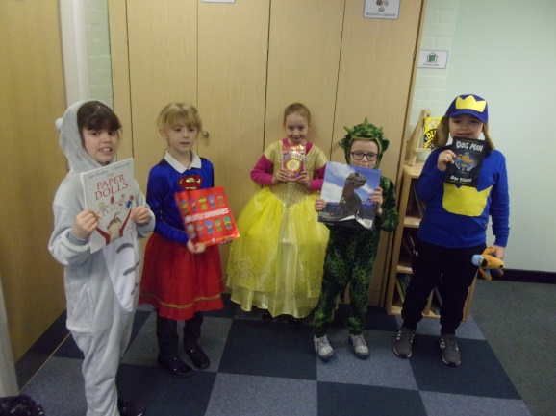
From book scrutinies and surveys that have been completed throughout this year it is clear that as a school we still promote high standrds in English, which is apparent by the progress achieved by the vast majority of our school. All of the work reviewed shows that staff have been using the new long term English plan which is linked to our Dimensions curiculum. These books show the skillful way staff disect each genre and writing style, which enables pupils to reach their maximum potntial. Reading has remained a real strnegth with pupils completely chaning their attitudes and appraoch towards reading and developing a love of reading.
Ways forward
Next year, as well as continuing to endorse reading for pleasure throughout the school I will be focusing on further developing the mastery of English at OM, through continued exposure to the full reading and writing journey as well as a phonics programme catered to the changing needs of pupils.
Details of how this will be achieved are in the school development plan for next year.

