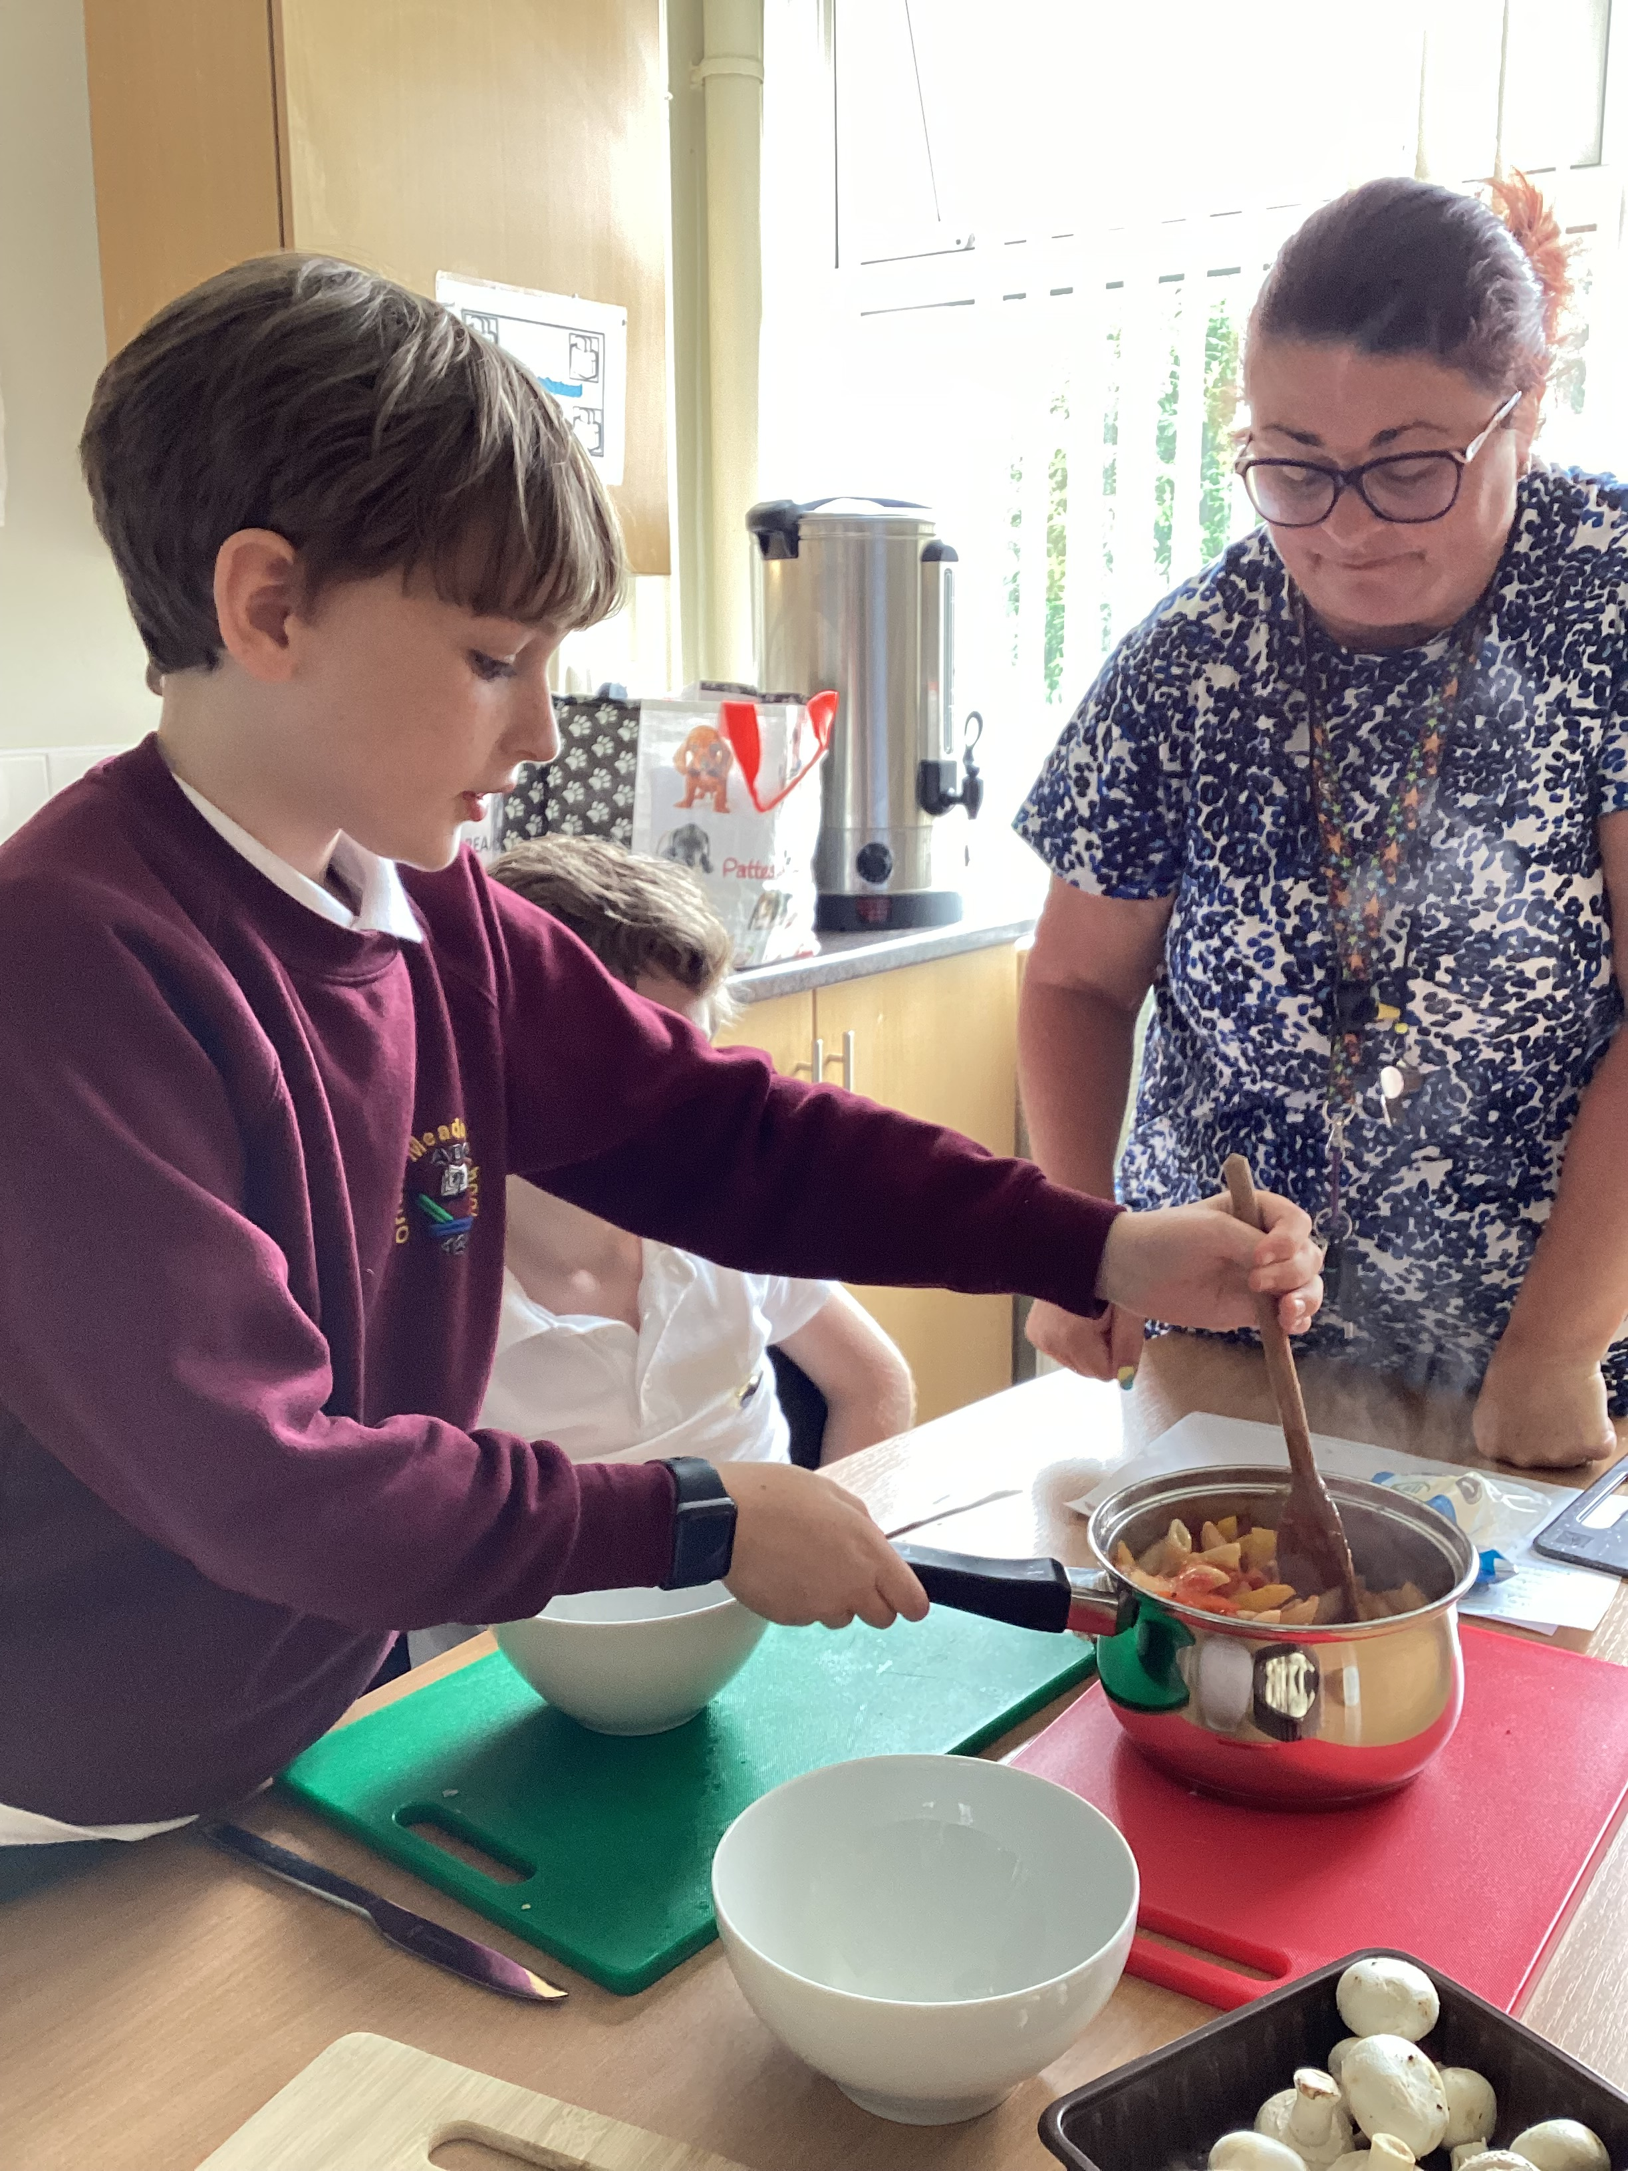
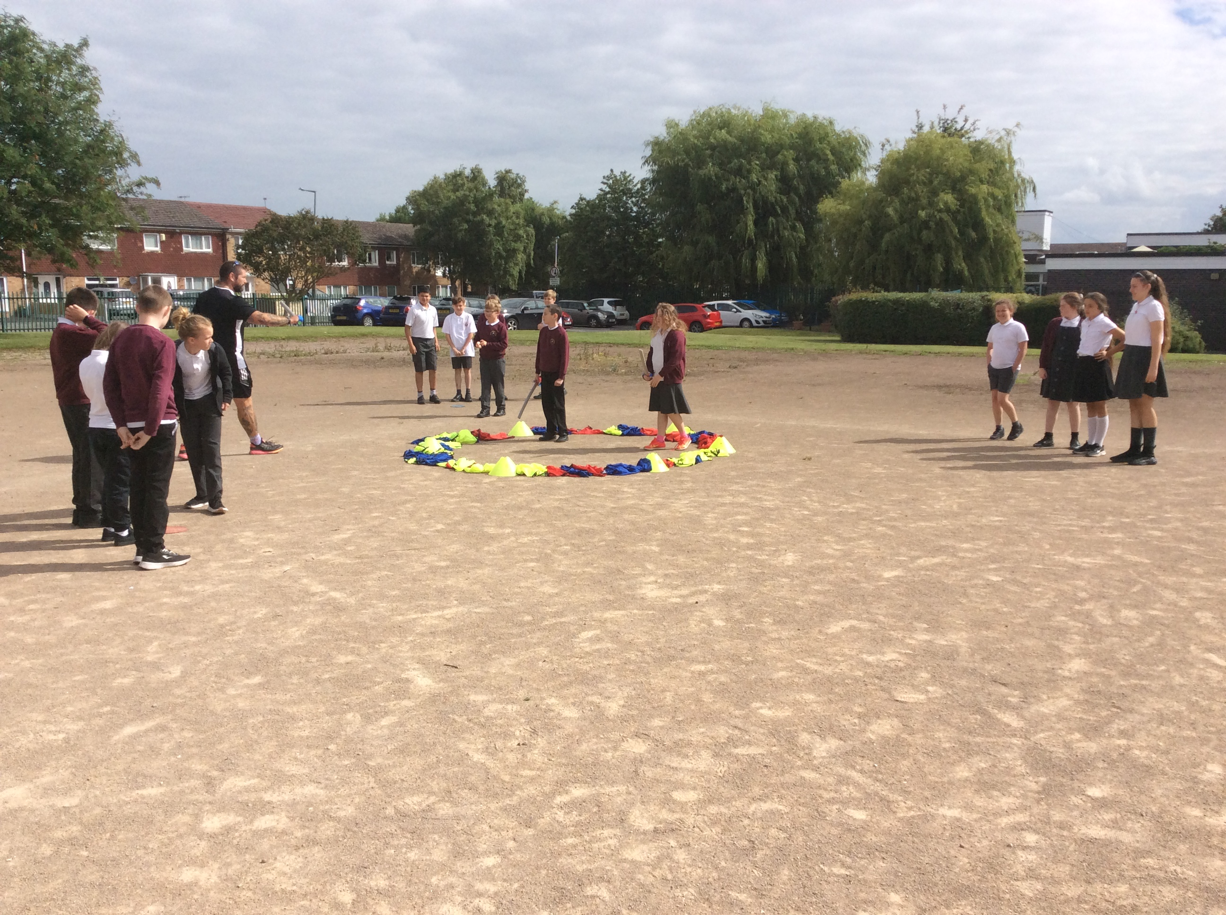
Governors Report – Summer 2022
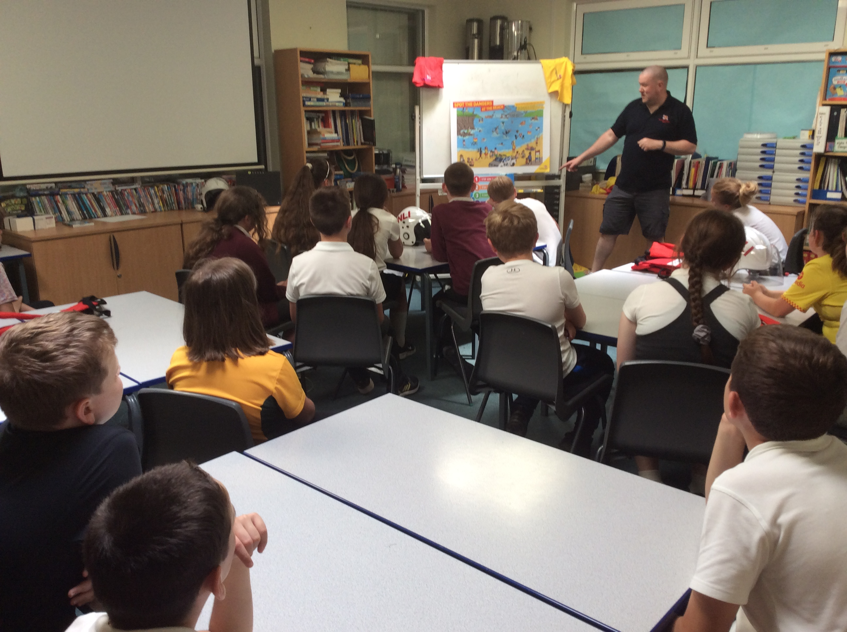
PSHE
Roz Warren
Achievements
The ‘ways forward’ identified last year from this year’s school development plan and the actions taken:
Resources purchased to support the teaching of bodies, sex and health to younger minded children
As subject lead I attended a ‘Puberty’ CPD session by Julie McCann by School Improvement Liverpool. She recommended books especially designed for Autistic children to support them learning about their bodies, sex and health. We purchased these books and the feedback from the Year 6 teachers suggested they were an extremely useful resource. Several websites and videos were also flagged to the Year 6 teachers from this training.
Each Class accessed a Independence Skills afternoon during Being Healthy and Safe Week
Our Autism Tracker data analysis highlighted Independence as the area that most needed developing. An Independence afternoon was timetabled during the Being Healthy and Safe Week. During this the children learnt some of the following independent skills; making a bed, making a drink of juice, making a piece of toast and buttering it, hanging out washing, folding clothes, doing up fastenings on clothes and crossing the road. It was a hugely successful afternoon and will be included in each Being Healthy and Safe Week in future.

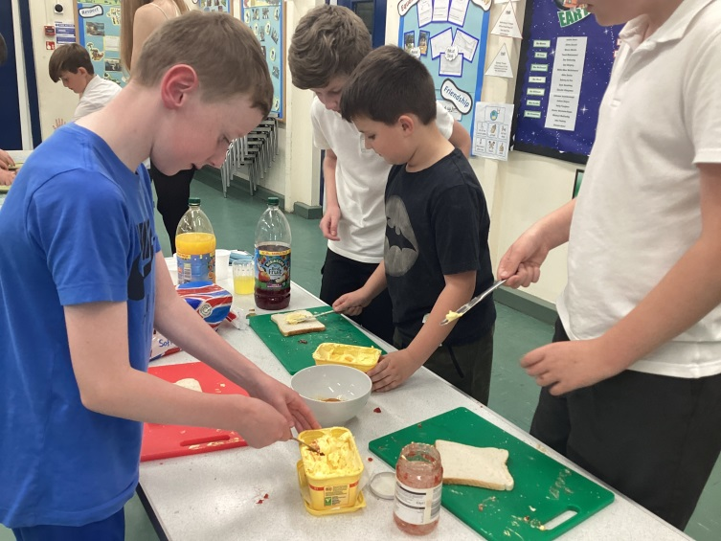
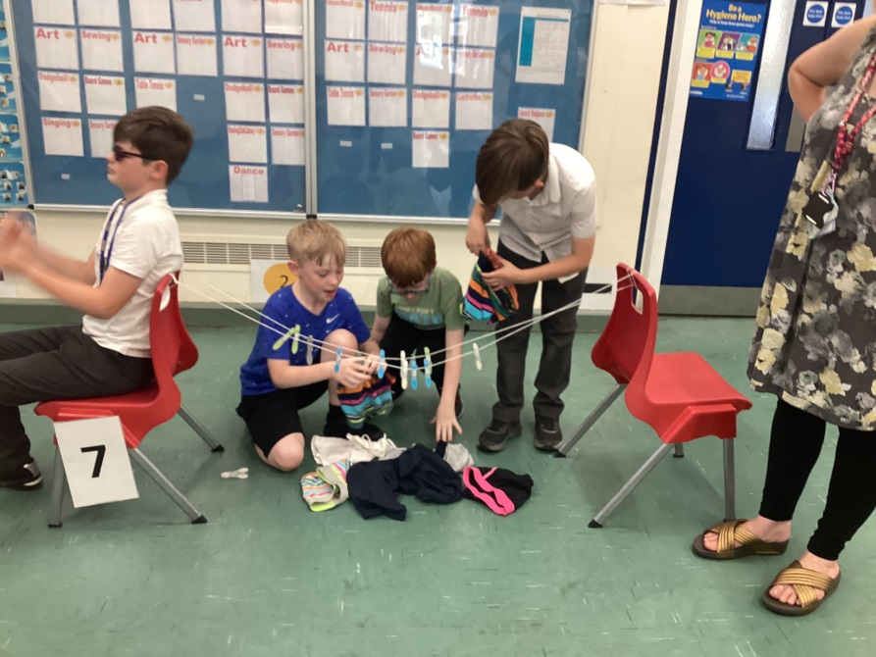

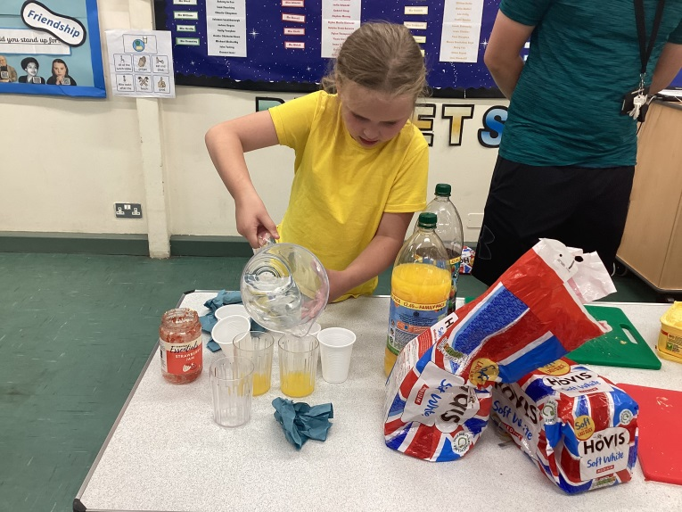
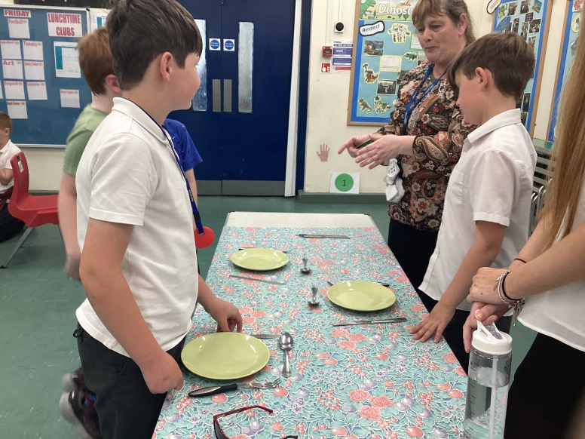

A informative Inset was held on developing independence skills
David Saul held an INSET day on Independence and Social Skills. It was an extremely interesting day. The staff learnt about new resources, practised using existing resources, and looked at the breath of coverage from starting point to Year 6. They also took part in practical tasks.

PSHE plans have been quality assured
As the PSHE lead I have quality assured the PSHE planning and ensured we have the required coverage. The long term plans were adapted and extra content was added to free up the Being Healthy Week for more practical tasks.
A successful ‘Being Healthy and Safe’ week
We had another extremely successful ‘Being Healthy and Safe’ Week this year. We had a range of visitors including; Claremount Wake Up and Shake Up, MW Multi-Sports, Yoga, Nurse Harris, the Fire Brigade, the Police, Yoga and Mindfulness sessions. Classes also visited the beach for a litter pick and visiting the Philharmonic Hall for a music event. Internally we did the magic mile, art sessions, design technology food projects (linked to healthy eating), pet corner, litter picking in our local area, circuit training and independence sessions. We also organised a transitional afternoon for our Year 6’s at Claremount where they accessed a golf session and met the Year 7 staff. It was an enjoyable action packed week which we have evidenced through photographs on Face Book.

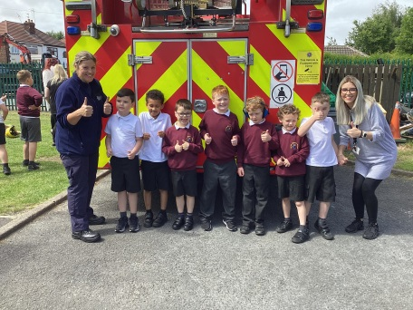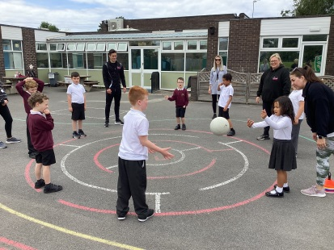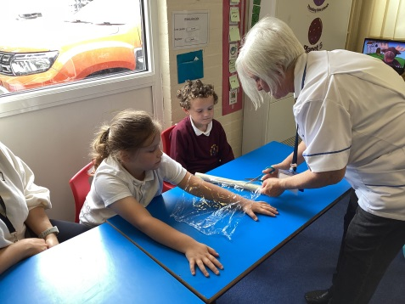

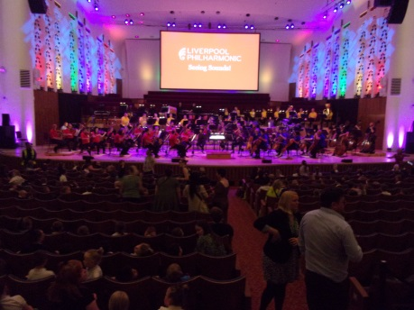
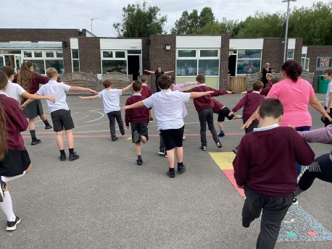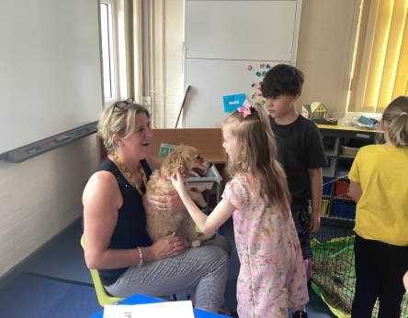
We accomplished the Autism Accreditation
We achieved the Advanced Status in the Autism Accreditation which is a huge achievement as not many schools achieve it. The assessor was extremely positive about our provision.

CPD
PSHE Lead
This year as subject lead I have accessed the following courses:
- Termly PSHE briefings
- Effective Teaching to prepare Children for Puberty 16th March ‘22
- Preparing for Ofsted through PSHE 21st June ‘22
Staff Training
During staff meetings I have reflected on PSHE updates, given book scrutiny feedback and discussed any adaptation to the planning. It was an opportunity to share good practice and discuss and share different activities that had been successful in our delivery of PSHE. David Saul held a whole school INSET on Independence and Social Skills which was an extremely beneficial day for all staff.
The staff have also accessed training from an external agencies:
- Hope School – Trauma and sand therapy
Quality of teaching and learning
As the PSHE subject leader, I have completed a range of activities to oversee the teaching and learning of PSHE this academic year. I have collated and analysed the ASD Framework Data, Scrutinised the PSHE books against the planning, been on a learning walk and conducted staff and pupil voice surveys on RSE, Dimensions, and the Year 6 teachers on the Sex and Health Education lessons taught.
ASD Framework
The ASD Framework continues to give us supportive data on the children. All new children were baselined during the Autumn term and existing children’s ASD Frameworks have been updated accordingly. The IEP (Individual Education Plan) continue to reflect this and therefore gives future targets for children in the highlighted areas of need. The whole school area of strength this year came out a social interaction and the area for development came out as Independence and community. We promoted independent skills as mentioned above.

PSHE Book Scrutiny
PSHE books continue to include photographic evidence or work for each lesson. Teachers display a range of multisensory learning opportunities to try and engage and create sticky knowledge opportunities. PSHE book scrutinises have taken place each term to moderate coverage and work evidenced. The statutory RSE content is demonstrated for each class within their books.

Learning Walk
My learning walks were an extremely positive experience. The vast majority of children showed high levels of engagement, participation and it was clear that learning was taking place. I witnessed a range of different teaching activities that the teachers had planned carefully to support the children’s knowledge building.

Pupil Voice
Out of the 67 pupil’s that were surveyed:
I enjoy PSHE lessons | 85% of pupil’s enjoy PSHE
I can tell my teacher some of the things I learn in PSHE (using book) | 93% of pupil’s could tell their teachers something they have learnt about in PSHE
My teacher teaches PSHE using lots of different activities | 85% of pupil’s feel that PSHE is taught through lots of different resources
The activities in PSHE are interesting and engaging | 91% of pupil’s find PSHE interesting and engaging.
I feel comfortable sharing my ideas, views and opinions in PSHE | 82% of pupils feel comfortable sharing their views

Staff Voice

Does the Dimensions curriculum support you to teach the children in PSHE? | 100% of teachers agreed that Dimensions supported the teaching of RSE.
Do you feel confident teaching the revised RSE content? | 100% of teachers feel confident teaching RSE.
Are the majority of RSE lessons easy and straight forward to deliver? | 100% of teachers agreed that the RSE lessons were easy and straight forward to deliver.
Is it easy to resource your PSHE sessions? | 100% of teachers agreed it was easy to resource PSHE.
Do the children demonstrate a positive attitude and engagement with the PSHE curriculum? | 100% of teachers say that children demonstrate a positive attitude and engagement with the PSHE curriculum.
Do you feel confident in teaching the different areas of PSHE? | 100% of teachers feel confident teaching the different areas.
Do you need any support in PSHE? | 100% of teachers do not require support

Year 6 staff Sex and Health Education Questionniare
- Staff felt confident teaching Sex and Health Education.
- Staff felt Dimensions sessions were easy and straight forward to teach.
- Staff felt some lessons needed adapting but felt comfortable doing this. Both classes used the BBC recommended video and this had positive feedback from parents.
- Staff felt children were mature, open and honest. They asked good questions and learnt a lot. In Sharks they were particularly interested in puberty. A few children in Owls found it a little awkward at times due to the content.

- Strengths
- Autism Tracker
- Independence afternoon
- Being Healthy and Safe Week
- Visitors coming in to promote different area i.e. Firefighters, Police, Yoga, Nurse
- The enthusiasm for teaching PSHE and the children’s response
- Autism Accreditation Advanced status

Ways forward - Targets
- To hold more independent sessions throughout the school year (1 per term)
- To support the lower cohort in developing emotions through researching resources and methods other schools use (Spring)
- To look through the plans and see whether we can do more active outside sessions in PSHE (from pupil data analysis - look at in Autumn Term)

