Governors Report – Summer 2021
Computing
Matthew Ferris
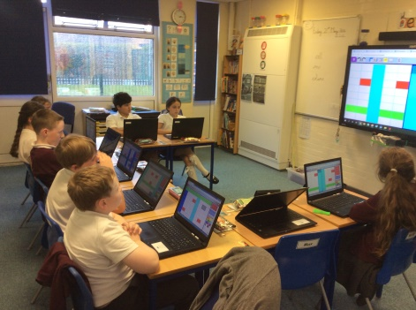
Achievements
During this academic year, computing has continued to be taught discretely in weekly computing lessons every other half term. As well as this pupils have also enjoyed a high level of cross curricular computing through our afternoon dimensions topic. Both staff and pupils have commented on their enjoyment of using their computing skills within topic lessons. This year a new assessment system for computing has been trialled in order to monitor the impact and progress within computing. Pupils have also continued to engage with the computing certificates, which have been amended to focus solely on the development of pupils’ basic skills.

CPD
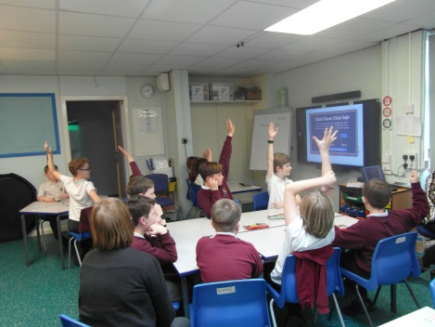
Despite the Covid restrictions, I was able to attend some CPD opportunities this year via Zoom calls. I took part in the School Improvement Liverpool Primary Computing subject leader meetings each term which were very informative regarding changes in the curriculum and different strategies used by schools across Merseyside to help children catch up upon their return to school.
This year I have been able to signpost staff to online courses in order to develop key areas, such as Primary Computing courses from Future Learn. Covid did provide the opportunity for teachers to engage in the Computing at School showcase which was held virtually. This provided staff with the opportunity to attend a range of courses and talks from key figures in the computing world. There were workshops for programming, unplugged activities, key skills in early years and many more.

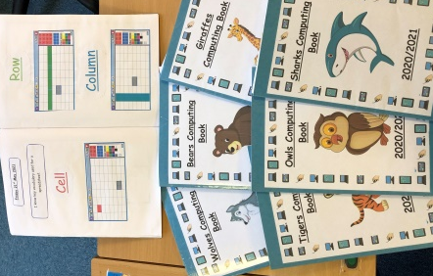
Quality of teaching learning
As the computing subject leader, I have completed a range of activities to oversee computing this year. During the autumn term, I created my subject leader file, ensuring all important documents were available such as the computing policy, which I updated in June 2020, the Primary Computing National Curriculum and the progression of skills for computing, which I created in June 2020. I carried out a book scrutiny in December 2020 in order to monitor how computing was evidenced around the school. This highlighted an issue with evidencing, as some classes had work on the class drive, purple mash, their own personal work spaces and paper copies in folders. I implemented a whole class computing book in order to collate evidence of discrete lessons.
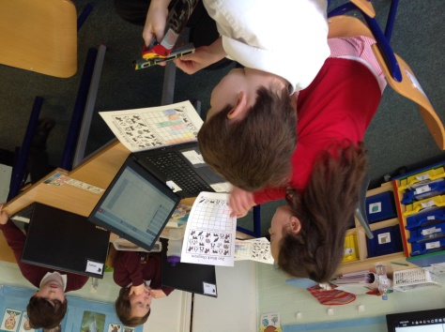
In the spring term, we faced another lockdown, which meant that during our half term of discrete computing lessons many pupils were not in school. Pupils were able to access programming software through Purple Mash, which also gave instructional videos of how pupils could create algorithms. The majority of classes in the school continued to deliver discrete computing lessons during this time, dependent on numbers within the class. After discussion with the PSHE lead, it was decided that we could incorporate computing into the being safe and healthy week in the summer term in order to help pupils catch up.
In the summer term, I conducted a staff and pupils survey in order to collect information to inform next year’s direction for the subject. Feedback was extremely positive from both staff and pupils, with the majority of pupils stating that they feel safe while engaging with technology in school. I also carried out a book scrutiny of the whole class scrap books in order to review how evidence is presented throughout the school and if lessons reflect the progression of skills.
Strengths
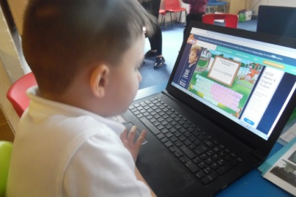
From the moderations and learning walks that I have conducted, I have been able to gain a greater view of how computing is delivered across the school, especially how the skills are differentiated in order to make them accessible to all kids. Having discrete teaching of computing throughout the year has been extremely beneficial for pupils; they are not only exciting, engaging and allow children to build on their abilities as end users, but they enable pupils to focus on developing their basic digital literacy skills. The teaching of computing is extremely varied at Orrets Meadow as the teachers are extremely adept at differentiating all lessons in order to meet the range of abilities within their class.
Ways forward
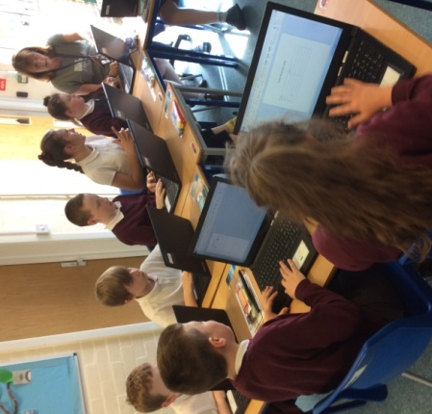
Next year, I will be continuing to focus on improving both pupil experience within computing by increasing pupils exposure to a range of technology and improving the evidencing of the fantastic computing teaching that is present within Orrets Meadow.
2021-2022 targets:
- To research and update the schools roamer selection. (Autumn 2021)
- To continue to monitor and support staff with collecting
evidence for computing. (Ongoing 2021/2022)
- To lead a staff meeting focusing on unplugged activities
(Autumn 2021)
- To research hardware and apps that could further improve the delivery of computing at Orrets. (Spring 2022)

