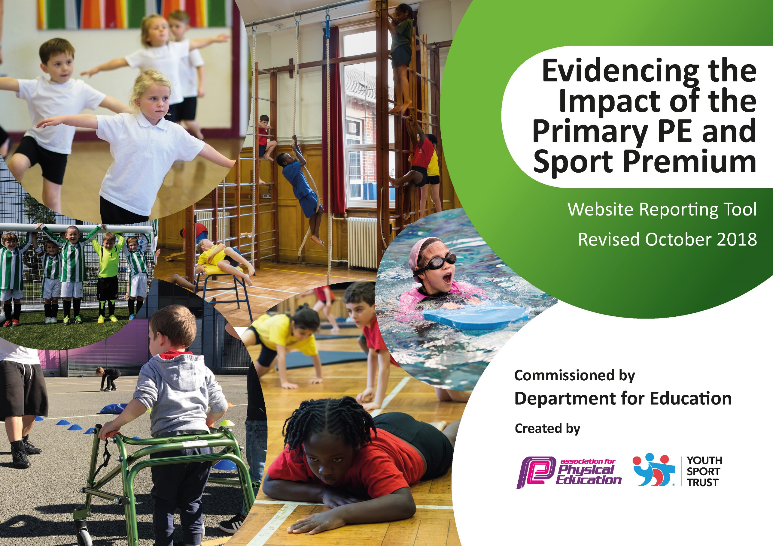
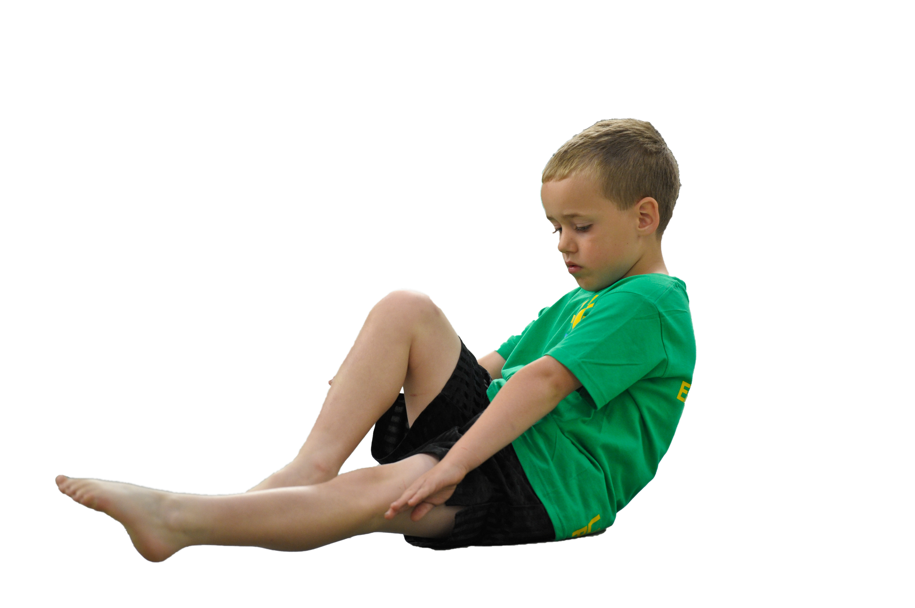
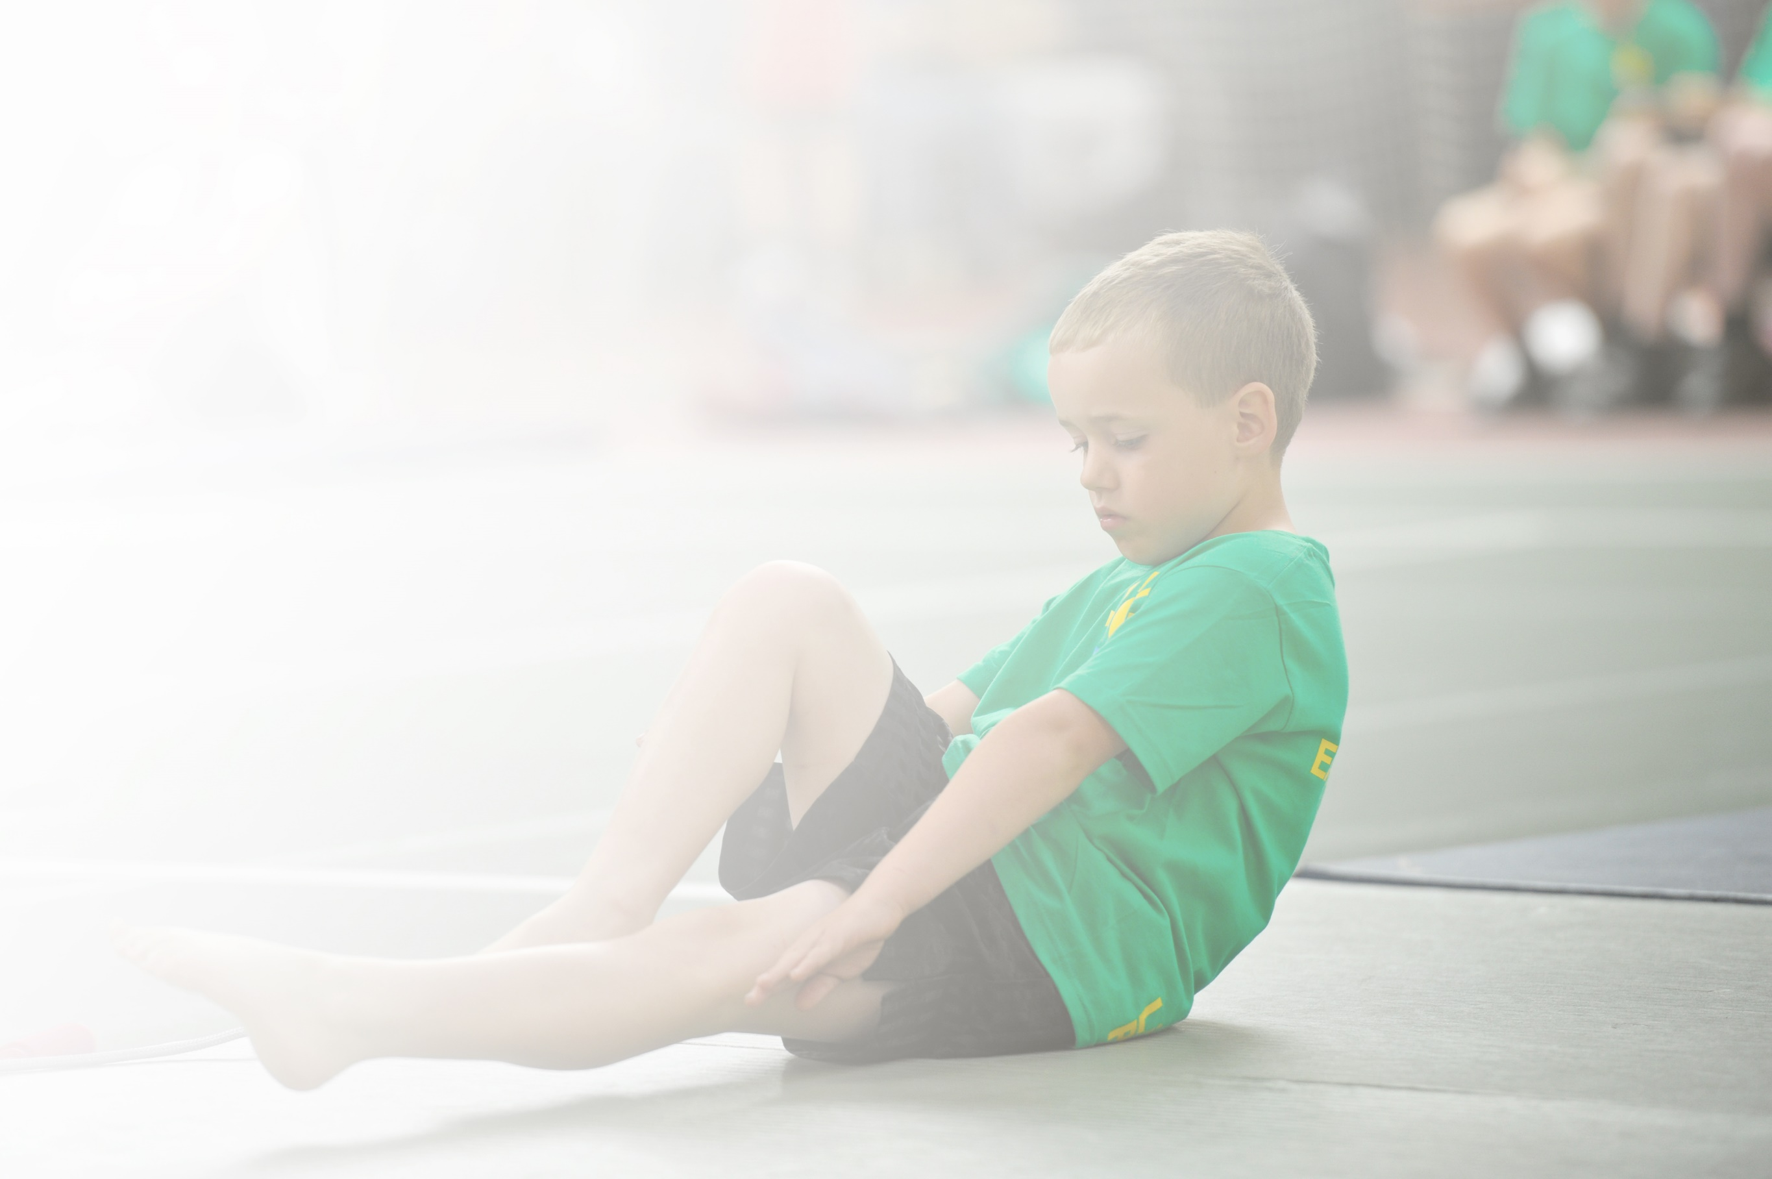
Schools must use the funding to make additional and sustainable improvements to the quality of Physical Education, Sport and Physical Activity (PESPA) they offer. This means that you should use the Primary PE and Sport Premium to:

- Develop or add to the PESPA activities that your school already offer
- Build capacity and capability within the school to ensure that improvements made now will benefit pupils joining the school in future years

Please visit gov.uk for the revised DfE guidance including the 5 key indicators across which schools should demonstrate an improvement. This document will help you to review your provision and to report
your spend. DfE encourages schools to use this template as an effective way of meeting the reporting requirements of the Primary PE and Sport Premium.

We recommend you start by reflecting on the impact of current provision and reviewing the previous
spend. Under the Ofsted Schools Inspection Framework, inspectors will assess how effectively leaders use the Primary PE and Sport Premium and measure its impact on outcomes for pupils, and how effectively governors hold them to account for this.

Schools are required to publish details of how they spend this funding as well as on the impact it has on pupils’ PE and sport participation and attainment by the end of the summer term or by 31 July 2022 at the
latest.
We recommend regularly updating the table and publishing it
on your website throughout the year, as evidence of your
ongoing review into how you are using the money to
secure maximum, sustainable impact. To see an
example of how to complete the table please
click HERE.

Support for review and reflection - considering the 5 key indicators from DfE, what development needs are a priority for your setting and your students now and why? Use the space below to reflect on previous spend, identify current need and priorities for the future.

Key achievements to date: | Areas for further improvement and baseline evidence of need:
- High profile of PE and sport (on school development plan since 2013; AfPE Quality Mark with Distinction 2017; Merseyside Sport Primary School of the year 2016)  - School Games Platinum Award (July 2019)  - Increased staff knowledge and confidence in PE due to coaching and mentoring (evidenced by HMI best practice case study 2014)  - Increased participation and engagement (evidenced by School Games Award for past 5 years) | - Developing further the physical health and wellbeing provision across the school as identified by the School’s Health Education Survey (SHEU).

Meeting national curriculum requirements for swimming and water safety | Please complete all of the below:
What percentage of your current Year 6 cohort swim competently, confidently and proficiently over a distance of at least 25 metres?  N.B. Even though your children may swim in another year please report on their attainment on leaving  primary school. | 70%
What percentage of your current Year 6 cohort use a range of strokes effectively [for example, front crawl, backstroke and breaststroke]? | 45%
What percentage of your current Year 6 cohort perform safe self-rescue in different water-based situations? | 40%
Schools can choose to use the Primary PE and Sport Premium to provide additional provision for swimming but this must be for activity over and above the national curriculum requirements. Have you used it in this way? | No

Action Plan and Budget Tracking
Capture your intended annual spend against the 5 key indicators. Clarify the success criteria and evidence of impact that you intend to measure to evaluate for students today and for the future.

Academic Year: 2021/22 | Total fund allocated: £16330 | Date Updated: March 2022
Key indicator 1: The engagement of all pupils in regular physical activity – Chief Medical Officer guidelines recommend that primary school children undertake at least 30 minutes of physical activity a day in school |  |  |  | Percentage of total allocation:
 |  |  |  | Approx. 20%
School focus with clarity on intended impact on pupils: | Actions to achieve: | Funding allocated: | Evidence and impact: | Sustainability and suggested next steps:
Increase physical activity levels of children across the whole-school | - Pitch Hire  - HSBC Ready Set Ride Programme  - Use SHEU survey to offer new clubs to less active children  - Fit Fun Fests in partnership with Clare Mount Specialist Sports College designed for less active pupils  - Full of Beans – 6x multi-skills sessions  - Active 30:30 Wristband Challenge (postponed to Spring 2022)  - Durham University project on Chief Medical Officer’s guidelines and recommendations  - Movement Matters project  - ‘Magic Mile’ | £1800  £200  Clare Mount Specialist Sports College SLA (£3500)  £300 | - Lunchtime Clubs, PE interventions and PSHE week (Spring/Summer 2022) have helped to encourage less active children to become more active:  - 100% enjoyed sessions  - 73% enjoy PE and sport  - 60% think they are now physically fit  - 100% feel they are better at physical activity  - 100% now feel PE and sport are important  - Full of Beans – Wolves, Bears and Giraffes have enjoyed 6 multi-skills sessions. Feedback very positive and some of the younger children are now participating at extra-curricular sports clubs.  - Owls class (Y6) have been working with Durham University to consult on the new UK government physical activity guidelines for physically disabled children and young people Physical Activity Guidelines. Posters they have collaborated on have been signed off by the Chief Medical Officer’s of all four nations of the UK!  - Y6 Children offering voice on physical activity and sport which feeds into Movement Matters future projects  - ‘Magic Mile’ – children and staff taken part in minimum of 15mins walk/run x3 per week. Positive feedback from children and staff.  - Fit Fun Fest March 2022: 10 children targeted by health and wellbeing data. The Paralympic Learning & Discovery Festival was a carousel of sports related activities, each station focusing on a different Paralympic sport. The activities on offer supported personal development through exploring team building, communication, confidence, self esteem and resilience.  - Fit Fun Fest (Transition) June 2022: 20 children enjoyed a festival trying a range of sports e.g. table-top games, tennis and Kinball. Emphasis on fun and friendship with transition a background focus.  - SEN inclusive football hub: weekly sessions at Clare Mount – open to all our Y5/6 pupils – 15 regular attendees.  - PSHE/Health week: yoga, mindfulness art, health and fitness circuits, dance, rugby, football etc. increased physical activity levels and mental health awareness | - Continue to provide a wide range of PE and sport activities (informed by SHEU and pupil voice)  - Physical Literacy project with Edge Hill University 2022-23  - Launch 60 second physical activity challenges (YST)
Key indicator 2: The profile of PESSPA being raised across the school as a tool for whole school improvement |  |  |  | Percentage of total allocation:
 |  |  |  | Approx. 20 %
School focus with clarity on intended impact on pupils: | Actions to achieve: | Funding allocated: | Evidence and impact: | Sustainability and suggested next steps:
Maintain high profile of PESSPA: further develop provision of PE and mental health (on SDP 2021-22)  Improve and support physical health, fitness and well-being of all pupils  Further develop leadership opportunities (main focus on girls) | - SDP includes PE and mental health as a priority  - PE report at governor’s meetings  - Termly PE staff meetings (focusing on different areas of CPD e.g. leadership, autism in PE, My Personal Best etc.)  - SHEU survey to highlight issues and trends and target support  - Mental Health and Keep Safe Week  - PE TA (Level 1) to help co-ordinate and lead range of extra-curricular sports clubs and support during PE lessons  - Girls Active (YST) with aim of leading whole-school fun fitness sessions and raise activity levels | £2500 TLR  payment  £2500 TLR  release time  £3500 (SLA)  £300  £400  £4000 | - DS and JW led staff CPD on ‘State of the Nation’ v Orrets Meadow Data. SHEU data was analysed and compared against national health and wellbeing trends. OM data positive when compared to national data (when considering SEN grouping). Staff more knowledgeable about national trends in health and wellbeing. Staff also know what priorities for OM are and how we will tackle them.  - SHEU survey informed mental health interventions throughout the academic year (in combination with CAMHS, Next Steps etc.)  - PE assistant provided personalised PE and sport interventions throughout year.  - PSHE/Health week: yoga, mindfulness art, health and fitness circuits, dance, rugby, football etc. increased physical activity levels and mental health awareness | - SHEU survey update and interventions planned for next academic year.  - Staff meetings to be led with Clare Mount each term linked to PE and school sport e.g. My Personal Best, STEP, autism in PE etc.  - Further develop the moderation of assessment for PE  - Explore the sharing of PE and sport practices and facilities with other schools

Key indicator 3: Increased confidence, knowledge and skills of all staff in teaching PE and sport |  |  |  | Percentage of total allocation:
 |  |  |  | Approx. 20%
School focus with clarity on intended  impact on pupils: | Actions to achieve: | Funding  allocated: | Evidence and impact: | Sustainability and suggested  next steps:
To further develop the confidence, knowledge and skills of all staff.  To provide bespoke targeted support of PE and sport to meet the needs of staff. | - CPD: staff meetings and from external agencies through partnership with Clare Mount Specialist Sports College  - Coaching and mentoring from TLR and specialist PE staff  - Opportunities for peer lesson observations (Summer 2022)  - TAs to use All About Autism e-learning course with support of JW and DS. | £3500 (SLA)  £2500 TLR  £2500 TLR release | - Teaching Assistants completed YST All About Autism course and completed certificated assessment. TAs being supported to apply training in lessons by JW and to showcase good practice. Lesson observations showing positive impact.  - JW follow-up CPD for TAs using All About Autism e-learning course. Planning, delivery, lesson observations and feedback focusing on TA use of inclusion spectrum, STEP etc. Very positive feedback from staff and JW observations.  - CPD (INSET) carried out by DS/JW/LP: Dance. Lesson observations have shown excellent use of this CPD in wide range of PE dance lessons and cross-curricular topic lessons.  - Staff have run extra-curricular sports clubs and activities Autumn 2021: cycling, basketball, volleyball, dodgeball, football  - SEND Shooting Stars CPD/Training March 2022 – girls with SEN. 2 teachers received training, piloted materials and will roll out in 2022-23. | - Mentoring of new teaching and support staff (employed for September 2022) by DS and JW using OM established coaching model.  - SEND Shooting Stars - 2 teachers received training, piloted materials and will roll out in 2022-23.
Key indicator 4: Broader experience of a range of sports and activities offered to all pupils |  |  |  | Percentage of total allocation:
 |  |  |  | Approx. 20%
School focus with clarity on intended  impact on pupils: | Actions to achieve: | Funding  allocated: | Evidence and impact: | Sustainability and suggested  next steps:
Provide a range of sports and activities for all pupils.  Offer a range of opportunities which some children may never experience out of school.  Offer activities and links which promote lifelong physical activity and positive mental health. | - Curriculum enrichment (e.g. judo, bikeability, fencing, OAA etc.)  - Extra-curricular festivals and event held by Clare Mount Sports College (e.g. BMX, in-line skating etc.) *Covid-19 permitting  - Full of Beans – 6x multi-skills sessions for 3 classes in autumn and repeated in summer  - PE TA (Level 1) to help co-ordinate and lead range of extra-curricular sports clubs and support during PE lessons  - Barnstondale residential Y6  - Little Hobbits OAA/Forest Schools | £1000  £3500 (SLA)  £300  £4000 | - Full of Beans – Wolves, Bears and Giraffes have enjoyed 6 multi-skills sessions. Feedback very positive and some of the younger children are now participating at extra-curricular sports clubs. Sessions repeated summer 2022.  - Bikeability: Y6 children received cycling tuition teaching practical cycling skills and road safety. Majority of Y6 children attained Level 2 qualification.  - Liverpool Football Club – LFC Foundation sessions . Y6 children received virtual sessions.. Impact has been increase in numbers attending extra-curricular football club.  - Inclusive football competition: every half-term. Children participated in inclusive competitive football tournament at Leasowe Recreation Centre.  - Judo – Year 6 children enjoyed a 6 week block of Judo with expert coach. Extremely positive feedback. Children displayed confidence, respect and responsibility.  - Extra-curricular lunch clubs e.g. football, basketball, volleyball, cycling, dodgeball  - PSHE/Health week: yoga, mindfulness art, health and fitness circuits, dance, rugby, football etc. increased physical activity levels and mental health awareness  - Barnstondale – y6 children enjoyed 3 day OAA residential involving activities such as climbing, abseiling, rifle-shooting, archery etc.  - Little Hobbits: majority of school have had opportunity for OAA sessions including activities such as: sensory play, messy play , tree climbing, bug hunting,  wood carving , campfire cooking , water play  and tool use | - Curriculum enrichment (e.g. judo, bikeability, fencing, OAA etc.)  - Extra-curricular festivals and events held by Clare Mount Sports College (e.g. BMX, in-line skating etc.  - Barnstondale residential June 2022.  - MLB First Pitch to be rolled out across more classes and/or as lunchtime club. Also add cross-curricula classroom lessons.  - Extend Little Hobbits provision across year to all classes.
Key indicator 5: Increased participation in competitive sport |  |  |  | Percentage of total allocation:
 |  |  |  | Approx. 20%
School focus with clarity on intended  impact on pupils: | Actions to achieve: | Funding  allocated: | Evidence and impact: | Sustainability and suggested  next steps:
Increase the overall number of children participating in competitive sport.  Increase physical activity levels and make a positive impact on children’s health and wellbeing. | - SHEU survey results to signpost children to their favourite activities and help design programme of events  - Clare Mount Sports College events  - Fit Fun Fests  - School Games Day and Level 1/2 events  - Local cluster events  - Girls Active programme | £150  £3500 (SLA) | - Inclusive football competition: every half-term. Children participated in inclusive competitive football tournament at Leasowe Recreation Centre.  - Fit Fun Fest March 2022: 10 children targeted by health and wellbeing data. The Paralympic Learning & Discovery Festival was a carousel of sports related activities, each station focusing on a different Paralympic sport. The activities on offer supported personal development through exploring team building, communication, confidence, self esteem and resilience.  - SEN inclusive football hub: weekly sessions at Clare Mount – open to all our Y5/6 pupils – 15 regular attendees.  - Fit Fun Fest (Transition) June 2022: 20 children enjoyed a festival trying a range of sports e.g. table-top games, tennis and Kinball. Emphasis on fun and friendship with transition a background focus.  - Intra-school house competitions | - Continue to offer wide range of activities and use SHEU survey data to inform planning of event  - SSOC (School Sport Organising Committee) training to help child-centred provision and planning  - Re-integrate with local cluster, holding face-to-face sports events  - School Games Day to be re-introduced in pre-COVID19 format  - Extend intra-school house competition

