Learning Means the World
Curriculum Programme
Explorers  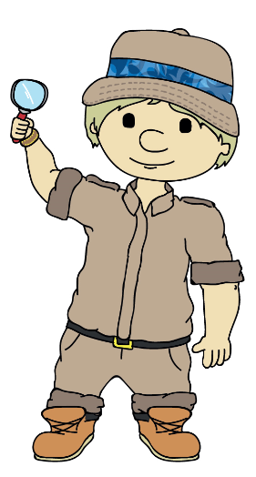 | Conflict |  | Culture |  | Communication |  |  |  | Conservation
 | Explorers A | Explorers B | Explorers A | Explorers B | Explorers A |  |  | Explorers B | Explorers A | Explorers B
 | Help is at Hand | Let’s Play | Under the Sea | Come Fly with Me! Asia | Happy To Be Me! |  |  | Tell us a Story! | No Place Like Home | What On Earth...?
 | Pupils will learn about the variety of ways in which people help them and how they can help others under the headings:-Help is at home, help is at school, police, fire, ambulance, doctors and nurses, other helpers and helping others.  They will find out about service-led roles within the community, as well as identifying ways in which they can help those in need by sharing their time and  resources. | . The unit starts with the pupils talking about their favourite toys and why they are special to them. They will discover how teddy bears are made. They will make their own toys and learn about famous constructions. The will play games and learn the importance of sharing, turn taking, following instructions and playing by the rules. They will design their own game. | By using three story- based texts, ‘The Rainbow Fish’, ‘Nugget  and Fang’ and ‘The Lonely Lobster’, pupils learn about friendship and the importance of respecting others whilst finding out more about life below the sea.  Focus areas include funky fish, sharks, whales and dolphins and crazy crustaceans. | Based on the continent of Asia, the pupils will travel by magic carpet to explore China, India, Russia and Egypt.  Pupils will learn about each country’s culture, food, music, weather, important buildings, traditional dress, festivals and dance. They will discuss similarities and differences between the countries and about being friends with someone who is different to you. | Pupils will learn more about themselves under the headings:-Who am I? eyes and ears, fingers, toesies, mouths and noses, similarities and differences, who’s in my family? And belonging.  They will discover what makes them unique, while at the same time learning to appreciate how they are connected to others, not only by the way they look, but  also through shared experiences. They will learn about their senses with a particular focus on listening and how we communicate. |  |  | Pupils will listen to familiar stories and develop their knowledge of  traditional tales under the headings:- jack and the beanstalk, the gingerbread  man, snow white, Cinderella and learning to listen.  They will extend literacy skills, in particular speaking and listening, as well as broadening their repertoire of stories. | Pupils will learn about places that provide shelter for  different people and animals under the headings:- my house, different kinds of houses, pet’s homes, wild animals’ homes, unusual homes and tents, caves and dens.  They will understand why shelter is necessary for humans and animals and learn  about the wide variety of homes they live in. They will also gain an appreciation of  why we need to look after our homes and possessions. | Pupils will learn about the diversity found within our world, under the headings:-living things, pretty things, big things, small things, old things and new things.  They will gain an appreciation of the wonder of living in a world, rich in variety and form. This should lead to an understanding of the need to look after things, however seemingly small and insignificant.
Pathfinders  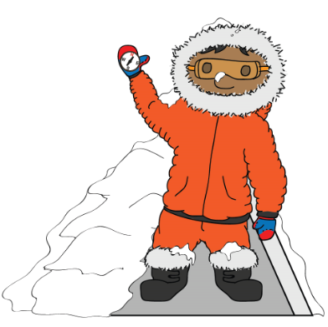 | Conflict |  | Culture |  | Communication |  |  |  | Conservation
 | Pathfinders A | Pathfinders B | Pathfinders A | Pathfinders B | Pathfinders A | Pathfinders B |  |  | Pathfinders A | Pathfinders B
 | Unity in the Community | Land Ahoy | Come Fly with Me! Artic Circle | Zero to Hero | Happily Ever After | Inter-Nation Media Station |  |  | Going Wild | Light Up the World
 | Based on the area you live in, with a geography focus. Pupils will develop their geographical skills, local knowledge and understanding through learning about their school, the features of its grounds, the surrounding area and how it has changed over time. They will be taught all about the importance of acting responsibly within both the school and the wider community | Subject focus on science and geography. The science element is based around sound, speed and motion and begins by exploring how things move, linking with a pirate’s journey around the continents and ocean. The unit concludes with an introduction to sound, focusing on sources of sound and the relationship between distance and volume. Threaded through is the theme of acting responsibly, with consideration for others. | Based on the Arctic region and surroundings, with a key focus on geography.  Pupils will learn about the location, weather and climate in the Arctic, as well as the wildlife that lives there. Inuit people, their traditions and customs, will also be studied. | History based unit about heroes and heroines, both past and present. They have all overcome major challenges in life and become inspirational figures: Michael Jordan, Walt Disney, Mother Teresa, Thomas Edison and Malala Yousafzai. | Based around fairy tales, with a key focus on literacy and drama. It is designed to enable pupils to develop a love of stories, as well as providing a vehicle for communication through creative arts works. | Based on media and broadcasting, with a key focus on history, through which pupils will learn about early methods of communication, leading to the invention of both the television and radio. Pupils will develop confidence in oracy, through opportunities to work on their own broadcasts. |  |  | Based around humans and animals, with a science focus. Pupils will look at humans and animals, beginning with characteristics of living and non-living things through to classifying birds, fish, amphibians, reptiles and mammals. There will be a particular focus on looking after animals and pupils will learn about extinction, wildlife conservation, habitat destruction and endangered species. | Based around the sun and other sources of light, with a science focus. Pupils will look at solar power and how to save electricity, as well as learning about sun safety and the importance of protecting both the skin and eyes. They will also learn about how shadows are formed when solid objects block light. Nocturnal animals will also be introduced in this unit.
Adventurers  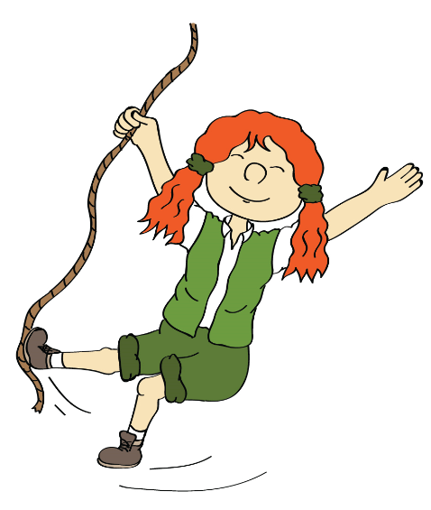 | Conflict |  | Culture |  | Communication |  |  |  | Conservation
 | Adventurers A | Adventurers B | Adventurers A | Adventurers B | Adventurers A |  | Adventurers B |  | Adventurers A | Adventurers B
 | Athens V Sparta | Law and Order | A World of Difference | Come Fly with Me! Africa | Lightning Speed |  | “That’s All, Folks!” |  | Picture Our Planet | Under the Canopy
 | Based on Ancient Greece, with a key focus on history. Learning is centred on how the Greeks used to live, including the key aspect of mythology, especially highlighting the conflicts that characterized Ancient Greece. | Based on the concept of justice, with a key focus on citizenship. Pupils will look at the importance of leadership and the meaning of democracy and its origins, before moving on to how this applies practically in communities, both school -wide, locally and nationally. | Based around world religions. It looks at the following faiths: Buddhism, Christianity, Hinduism, Islam and Judaism, examining aspects such as places of worship, holy books, core beliefs and important festivals | Based around the continent of Africa, with a key focus on geography and history. Pupils will learn about the location of Africa and identify its largest countries. Alongside this geography element, they will study the Benin era. They will also learn about African culture, in particular typical African food and folk tale. | Based around the history and development of the internet and World Wide Web, with a focus on computing. It primarily looks at how computers communicate, the importance of networks, how email works and how the internet enables collaboration. |  | Based around the history and development of animation and cartoons. It teaches the beginnings of animation, looking at zoetropes and flip books, before moving on to the dawn of the Disney age. Then, the process of animation is explored further, with an opportunity for pupils to exchange their own design ideas and create their own animated film. |  | Based on geography. Learning is centred around three contrasting localities: Brazil, Scotland and Fiji, and includes key facts, physical and human features, traditions and customs and an insight into how each country is tackling particular conservation. | Based on the rainforest with a key focus on geography and history. Pupils are commissioned to work for a fictitious organisation called ‘Roots’ in helping two adopted children find out about their Mexican/Mayan heritage and, as a result, find out more about the rainforest.

