23rd April 2024
Dear Parent and Carers

We are heading into our final term of this academic year. The Summer term is always a packed term with transition visits, sports day, Barnstondale, Summer fair and leavers’ assembly.

Summer dresses can be worn this term. Girls normally wear burgundy Summer dresses – these can be bought in local supermarkets. Also, as the weather improves children will not need to bring their coats to school, however, we do request you apply sun lotion before they come to school if the day looks sunny and hot. Sun caps can also be worn.

Ofsted
We are very proud to announce that we maintained being an Outstanding school and were given no ways forward. It is incredibly difficult to achieve outstanding on the new Ofsted framework and so to be awarded this is testament to the dedication and hard work of everyone at Orrets Meadow.

Our favourite quotes are;
“Pupils value being a member of this exceptional school community because they feel part of the Orrets Meadow family.”
“They speak highly of the support and kindness they receive from the committed staff team.”
“The school is a calm oasis for pupils”
“They thrive on close relationships they form with others”
“Pupils thrive at Orrets Meadow”
“School has soaring expectations for pupils’ achievement”
“Relenting ambition from everyone”
“Pupils make exceptional strides in their learning”
“The school’s curriculum is expertly crafted”

The full report was emailed out to all parents, is on the school facebook page and school website. It will shortly be available on the Ofsted website.

Barnstondale
The year 6 residential is next week! Medical forms must be sent in by Friday this week. If we do not have signed forms then we cannot administer medication. Mrs Duncan will go and visit the children after school each day and put photos on FB. Year 6 pupils say Barnstondale is one of their best experiences of Orrets.
Canopies
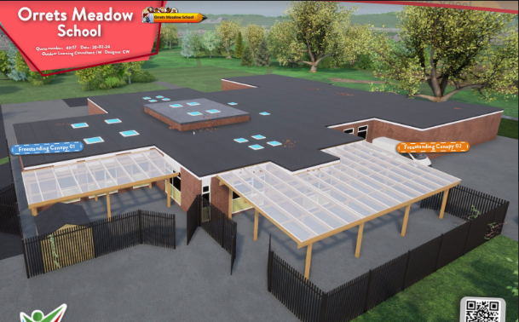
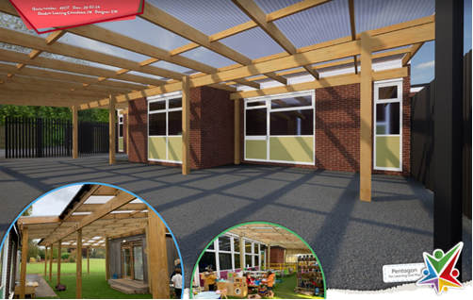
We are extremely pleased to announce that we have had our outdoor learning areas improved by having canopies installed in Bears and Wolves. We requested the funding from the Local Authority. The playground areas can now be used to promote outdoor learning whatever the weather and will transform our curriculum offer for our youngest pupils. Our plan now is to purchase lots of outdoor furniture to create outdoor classrooms.

Forest Schools
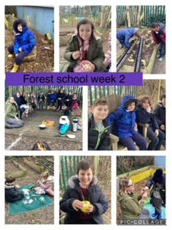
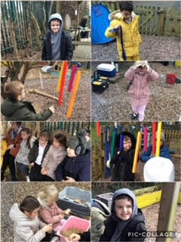
Zebras and Giraffes start their sessions this Thursday. Children can come to school in old clothes on these days. Each class will do 3 sessions to earn their Forest School Skills Award.

Bears and Wolves will start their 3 sessions Thursday 16th May.

Thank you to Michelle from Nestlings for providing such an excellent service.

School Jumpers
School jumpers can be ordered through the office for next year. Please send in how many you would like and the money. A uniform order form is attached to the newsletter.

Prices
Jumpers £12 (up to age 12)
Cardigans - £13
School bag - £8

Sports Day
Our annual sports days have been planned for July. Lets hope the sun shines! We have decided to do two sports day again this year, as we feel the younger children have a better experience and increased participation. Parents and carers are invited to their child’s sports day.
Zebras, Foxes, Sharks, Owls, Tigers – Friday 5th July 9.30 - 12pm
Wolves, Bears, Giraffes – Tuesday 9th July 9.30 – 11.30am
Important Dates

22nd April Language and Culture Week – whole school
24th April New Brighton – Zebras
25th April Forest Schools – Giraffes & Zebras week 1
26th April Chester – Giraffes
1st May Barnstondale – Year 6
2nd May Forest Schools – Giraffes & Zebras week 2
6th May Bank holiday
9th May Forest Schools – Giraffes & Zebras week 3
10th May Mad Science Assembly – Water
13th May SAT week – some Y6s will be entered for them if we feel appropriate.
16th May Forest School – Wolves & Bears Week 1
17th May DT Day – Food technology – whole school
20th May Science Week - whole school
21st May Tigers Science trip
23rd May Forest School – Wolves & Bears Week 1
24th May Whole school games day
W/c 27th May May Half Term –closed for the week
3rd June Inset day – school closed
4th June School opens

Future Notice
Year 6 swimming w/c 17th June and 24th June
2nd July – Dance Festival @ Floral Pavilion
Transition day for Y6 pupils to go to their new schools - Wednesday 3rd July.
Sports Day - 5th July 9.30 -12pm and 9th July 9.30-11.30am – Parents invited.
Pupils show parents books – w/c 15th July – invites to go out.
Leavers assembly and Summer Fair – Tuesday 23rd July 1pm – Parents invited.

More activities will be added as the term goes along.

Please make sure you check your emails regularly as this is the way we send important information to you. Also, if you would like to see photos of your child taking part in all of the exciting enrichment activities we offer at school, then please follow us on Facebook.

Thanks for all your support.
If you have any questions about any of the above, please contact me.

Mrs Duncan

