26th January 2024
Dear Parent and Carers

Happy New Year! I can’t believe how fast time is flying and January seems to have gone in a flash. Below are some key things for your calendar as we have lots of exciting things planned for the children at Orrets.

School Lunches
Our new lunch of home made sausage roll and spaghetti hoops has gone down a storm! Please look on the website each day to see what we are having and if they wish to try a meal please send in £2.50 or if you are on Free School Meals then you are entitled to it. We will continue to look at the meals and adapt them according to the children’s requests….. and try to stay within the healthy food guidelines!

Child and parent session
Thank you to all the parents who attended the child/parent session in December and looked at their books with them. I think you will all agree the amount of work and progress they are making is unbelievable and it does show that when the provision is right their learning flourishes. We are planning on another child/parent session in the Summer term, so you will then be able to clearly see the progress made from the beginning of the year to the end.

Parent Coffee Mornings
We have coffee mornings booked in with different guest speakers. Please try to attend as the more information you gain from professionals, the more you will be able to support your child in the home. Here are the coffee mornings booked for this term:

Thurs 18th January 10-11 Camhs – supporting your child with masking
Thurs 29th February 10-11 ASD – What is ASD and how do we support children in
school with ASD
Thurs 7th March 10-11 Sensory Therapist – Supporting children with sensory
Processing
Ready for school
Please can you make sure your child is ready for school and learning each day by remembering to send in their school bag with their communication book and reading book in it. The children should also have their PE bags in school every day.

Forest Schools
Bears and Wolves continue with their Forest School sessions until the end of half term. Please remember to send them in old clothes and with a warm coat. After half term we will start the sessions again with each class having 3 weeks to earn their Forest Skill badges!

Photos of the sessions go on Facebook each week and I think many children will say it has been a brilliant experience for them, both in terms of enjoying the outdoors but also in supporting them develop their social and life skills.

Year 6 Hoodies
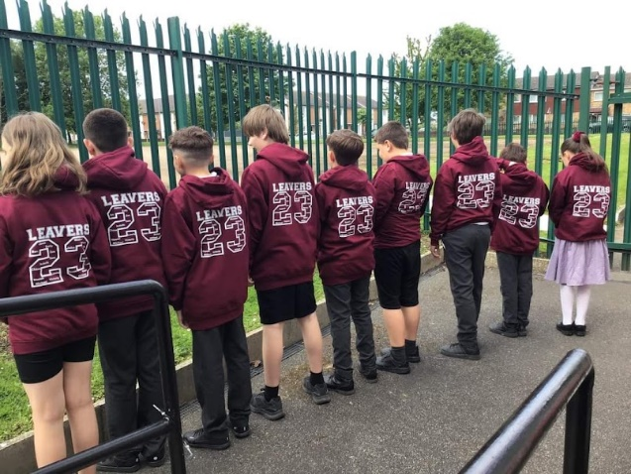
The PTA are ordering school hoodies for the Year 6s to take to Barnstondale in May and they can wear them in school.

Here is a photo of them from last year and the children loved them! This year they will have the number 24 (Class or 2024) on them and inside the number will be all their names.

Letters have gone home in school bags.

Important Dates

1st Feb Forest Schools Bears and Wolves wk 3
W/c 5th Feb RE week – all classes
7th Feb Year 6s - Height and Weight
8th Feb Forest Schools Bears and Wolves wk 4
W/c 12th Feb Science Week – all classes
15th Feb Forest Schools Bears and Wolves wk 5 (last one)
16th Feb Non Uniform Day – Bring in £1
Finish for half term at 3.30pm
26th Feb Return to school as usual

More activities will be added as the term goes along.

Please make sure you check your emails regularly as this is the way we send important information to you. Also, if you would like to see photos of your child taking part in all of the exciting enrichment activities we offer at school, then please follow us on Facebook.

Thanks for all your support.
If you have any questions about any of the above, please contact me.

Mrs Duncan

